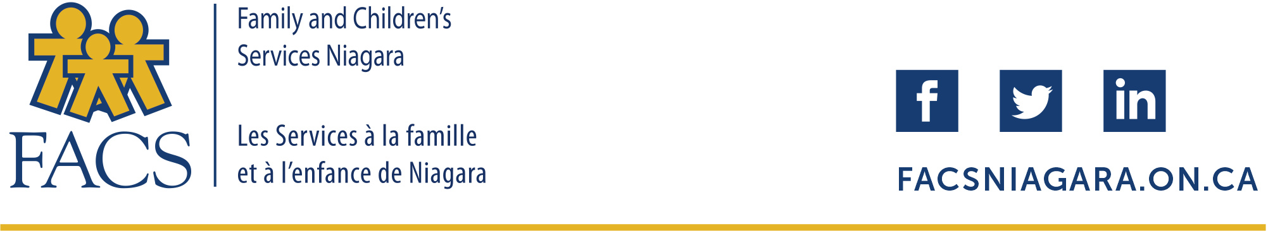
UPDATE
FACS Niagara and Covid-19
Frequently Asked Questions
April 15, 2020

- Is FACS Niagara continuing to provide services?

Family and Children’s Services Niagara and the Family Counselling Centre are not closed. While we have temporarily closed some of our physical locations to support physical distancing, we continue to provide services to the entire Niagara community.
FACS Niagara and all Children’s Aid Societies have been declared essential services by the Province of Ontario.

- What services are closed or not available at this time?

Although we have temporarily closed our Welland and Niagara Falls locations, we continue to provide services remotely, and from our St. Catharines headquarters at 82 Hannover Drive.
Our Family Counselling Centre and Walk-In Clinics are closed and are providing services remotely as well.
Our two childcare centres in St. Catharines have temporarily closed and we have suspended our child development assessment services.
Additional services that have been suspended, or postponed at this time include: groups operated by our Family Enrichment Workers, Crown Ward Championship Team events such as school visits and celebration dinner and events such as our foster parent/volunteer appreciation dinner and our annual general meeting

- Will FACS respond to my calls?

Yes. FACS is available 24/7 to respond to your child protection concerns.

- How do I report my concerns about the safety and well being of a child or family in my community?

Call us at (905) 937-7731 or toll free at 1-888-937-7731. Please do not use Facebook or Twitter or other social media platforms to share child protection concerns.

- Will FACS visit a family, child or youth in person?

Yes. Although we are limiting face-to-face contact to reduce the spread of the virus, we will respond in person where needed and we will employ protective equipment, screening and other health and safety measures as recommended by Public Health authorities.

- What is FACS doing to limit the spread of the virus?

- We have temporarily closed a number of our physical locations and are primarily working remotely.
- Additional cleaning and screening measures have been employed, as well as the use of personal protective equipment.
- Staff are advised to observe the direction of local health authorities, with regard to travel, self isolation and physical distancing.
- Meetings and events have been postponed or are being conducted remotely.

- What services are still available? How can I access them?

We continue to provide child protection services. We are responding to community concerns and supporting those families in the community currently receiving services. We continue to support our foster families, and those children and youth in foster care. We are also supporting those youth in our care or under our supervision, living independently in the community.
Please call (905) 937-7731, 24 hours a day, 7 days a week, for child protection services or toll free 1-888-937-7731.
Our Family Counselling Centre is providing phone and video counselling services. With support from United Way Niagara, we are currently offering free counselling sessions. Please call to book an appointment or session. Call (905) 937-7731 ext 3345 during regular business hours.
The Family Counselling Centre is currently offering a special counselling program for essential service workers. Employers should call (905) 937-7731 ext 3326 to find out more about our “Helping the Helpers” program.

- What about court hearings or appearances?

FACS Niagara continues to exercise its mandate in relation to court matters. We have received specific directions from the courts regarding how to handle matters, while adapting to our current circumstances. Presently we are focusing on urgent matters, filing documents electronically and conducting appearances by teleconference. At this time non-urgent matters are being adjourned to dates in early June.

- What about family visits?

Family and Children’s Services recognizes the importance of maintaining and strengthening family bonds. To that end, we have undertaken several initiatives to preserve and ensure that family connections during these challenging times are maintained, while ensuring the health and safety of everyone involved.
Based on recommendations from Public Health authorities and the Ministry of Children, Community and Social Services, we are employing technologies such as Skype, FaceTime and phone calls to maintain contact, while at the same time implementing measures, wherever possible, to ensure safety.
Every family situation is unique. We continue to review face-to-face visits on a case-by-case basis, evaluating and considering the distinct circumstances of each child and family.

- Do you still need foster parents and volunteers?

We have an urgent need for foster parents.

The support of our foster parents and volunteers is critical to the mission of our agency.

We continue to take applications for fostering and volunteering. The application process can be completed via regular mail, by telephone and online. Please don’t hesitate to contact us.

- What can the community do to support the work of FACS and the families, youth and children that they serve?

During this unprecedented time, we are very grateful for your continued support and patience as we strive to provide services while taking measures to prevent the spread of the virus.
Many of our families are experiencing additional stress and isolation as their familiar supports are no longer available. Please visit our FACS Foundation web site or call to find out more about our COVID-19 Emergency Fund for children, youth and families.
Our families and youth need you now more than ever. Please be vigilant about children and families in the community who may need our help. Don’t hesitate to call.

Thank you for your support! We remain committed to serving children, youth and families in the Niagara community.
For updates and more information: call FACS, the Family Counselling Centre and FACS Foundation at (905) 937-7731.

Visit: facsniagara.on.ca
fccniagara.on.ca
facsniagarafoundation.org

We remain committed to our mission of: Safe Kids. Strong Families. Youth and Adults at their Best.

